Press Release  Egypt | 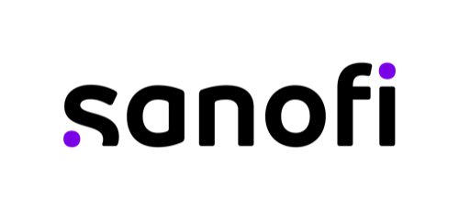

Sanofi reaffirms strategic healthcare partnerships to advance innovation and patient care in Egypt

Cairo, Egypt-April 7, 2025. On the occasion of the official visit of French President Emmanuel Macron to Egypt on April 7-8, 2025, Sanofi reaffirmed its commitment to advancing healthcare cooperation between France and Egypt by signing three agreements with the Egyptian Ministry of Health and Population. These agreements, which focus on vaccination coverage, diabetes and rare disease awareness, result from productive discussions between Sanofi and Egyptian health authorities.
HE Khaled Abdelghafar “The Deputy Prime Minister of Health & Population” witnessed the signatures of the agreements
The three agreements were signed by Adrien Delamare Deboutteville, Sanofi Head of Pharma Africa, Dr. Mohamed Hassany “Assistant Minister of Health and Population for Public Health Initiatives” and Dr. Amr Kandil “Deputy Prime Minister of Health and Population for Preventive Medicine, Public Health and Primary Care”.

HE Khaled Abdelghafar - Deputy Minister of Health and Population
“The Egyptian government is committed to improve healthcare services and increase medical investment. We also launched a new universal healthcare system that gives full medical coverage to all Egyptian workers. Public & private partnerships are key to reach our objectives as diseases awareness and health sovereignty. Sanofi is a trusted partner and well positioned to support Ministry of Health & Populations in achieving our 2030 healthcare vision.”

Adrien Delamare Deboutteville - Head of Africa Pharma and Country Lead Egypt
“These agreements represent our commitment to addressing Egypt’s healthcare priorities holistically. Beyond providing treatments, we are deeply engaged in contributing to strengthening Egypt’s healthcare ecosystem through relevant initiatives that focus on diabetes, rare diseases, vaccination coverage. We are pleased that both parties reaffirmed their dedication to working together to achieve significant health advancements.”

Christelle Saghbini - Head of Sanofi International Pharma, participated in a high-profile panel titled “Advancing Egypt’s 2030 Healthcare Vision: Strategic Partnerships with France” where she emphasized the importance of collaborative approaches in achieving healthcare transformation and advancing on innovation access for patients.
Christelle Saghbini - Head of International Pharma
“For over 60 years, Sanofi has evolved alongside Egypt’s healthcare landscape, adapting to meet the changing needs of patients while navigating the country’s dynamic environment. Today, we are not just providing treatments: we are working hand in hand with the Egyptian authorities to address the most pressing health challenges through strategic partnerships, healthcare professionals training, AI, and digital innovation. Our partnerships with Egyptian health authorities and local pharmaceutical companies like Gypto Pharma and Minapharm further demonstrate our dedication to enhancing access to essential medicines and vaccines.”

About Sanofi
We are an innovative global healthcare company, driven by one purpose: we chase the miracles of science to improve people’s lives. Our team, across the world, is dedicated to transforming the practice of medicine by working to turn the impossible into the possible. We provide potentially life-changing treatment options and life-saving vaccine protection to millions of people globally, while putting sustainability and social responsibility at the center of our ambitions.
Sanofi is listed on EURONEXT: SAN and NASDAQ: SNY

Media Relations
Aziz Yousfi Malki | + 212 6 61 35 71 99 aziz.yousfimalki@sanofi.com
Ghada Michel | +20 10 21 05 82 52 Ghada.michel@sanofi.com

